**Packaging Guidelines for next Tapeout**

-IO’s ( specifically the most active ones, clk for example ) should be centered in a side.

-VDD, DVDD & GND should be spread between IO’s.

Example pin sequence : GND - IO - VDD - IO - GND - DVDD - IO - GND

-Some package implements functionality to enhance signal integrity or to control impedance at IO level ( PLL & Clk specifically target in M.Taylor’s BGA ), so pinout has to be brainstormed according to the package choice before tapeout.

-IO wires should measure up to 5mm. [[source](http://extra.ivf.se/ngl/documents/ChapterA/ChapterA2.pdf)]

-Other wires should measure up to X value according to their diameter ( guidelines find in design document provided by wirebonding company, there is an example under the “for integra” Folder

-For next chip, if we use the same BGA package, it would be great to either enlarge the chip or use bigger cells to avoid taking a risk with too large gold wire compared to our BPO.

We can also ask for help regarding pin assignment, as it’s specified on M.Taylor website ( or just literally copy their pin assignment ).

**Glossary:**

-Passivation : Chip layer that provides electrical stability, information to be found in the foundry guideline document.

-Die Thickness : Specific to the foundry technology, standard.

-Die attach : Material to attach the die to the package, wirebond house typically use Epoxy Conductive.

-Wirebond material: Gold is the most suitable material for most applications, use aluminum if the top pad surface is low cost and will not support 120°C+ bonding process.

-Bond Pad Pitch (BPP) & Bond Pad Opening (BPO):

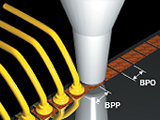

-Encapsulation: Package sealing method. Taping allows for easy access to the chip pad, epoxy is what bonding houses typically use.

- Dam and fill is a method of fully encapsulating wire bonded die. It’s a two-part process, wherein a dam is dispensed first around the periphery of the top of the component, followed by filling the center. This encapsulation approach allows to apply pressure on the package, as the resin once solid is solid enough to support the socket.

- Taped lids on rings : A lid is taped on a ring/spacer, this encapsulation is useful to check that the wire bonding company did the right job, & to do some photography.

**BGA specific :**

-Substrate form : Package outline.

-Substrate type / material : To be determined with the manufacturer. Typically FR-4, Rogers or BT.

-Substrate stackup : Drawing of the layer stack-up with thickness / material used per layer expected.

-Ball attach, pad opening size :

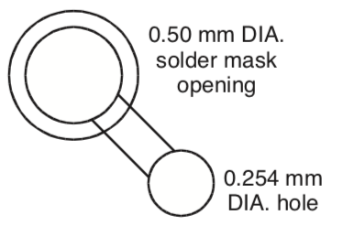

-Solder mask define : Bottom layer with design for an easy solder balling process. Not always the case.

[Example files to send to wirebond house from us.](https://drive.google.com/drive/u/0/folders/13VmuLknUgvIbsRPj9bHTYmwqb6FczScE)

[Example files to send to wirebond house from M.taylor.](https://bitbucket.org/taylor-bsg/bsg_packaging/src/master/ucsd_bga_332/pinouts/bsg_two/common/to_assembly_house/example_files_for_assembly_house/)